The Potential Role Of Vortioxetine and Dapagliflozin in Experimental Induced Ulcerative Colitis in Rats Via Alleviation of Oxidative stress, Inflammation and Apoptosis

Salwa A. Elgendy ,Omaima M. AbdAllah, AliBehairy ,TasneemG.Ismail,

Heba A. Elnoury.

Abstract:
Background: Inflammatory bowel disease is one of the most serious health problems. Vortioxetine (VRT) is SSRIs and SNRIs as it has multimodal profile. Dapagliflozin (Dapa) , is SGLT2 inhibitor which might suppress the expression of inflammatory cytokine. Aim of the study: This work was designed to assess the potential prophylactic effect of VRT and Dapa alone and in combination in acetic acid induced UC in rats . Materials and Methods: This study was conducted on 36 adult rats, divided into 6 groups; (I) normal rats, (II) Non treated UC group, (III) sulfa treated UC group received sulfa (100 mg /kg/ day, orally), (IV) VRT treated UC group received VRT (10 mg/kg/day, orally), (V) Dapa treated UC group received Dapa (5mg/kg/day, orally) and (VI) VRT and dapa treated group received combination of VRT (10 mg/kg/day, oral) and dapa (5mg/kg/day, orally).Results: Treated groups showed significant decrease in colon weight, CMI , colon weight / length ratio, increase in colon length, improved in body weight , decrease in DAI, serum iNOS , CRP, colonic TNF-α , increase of colonic IL10, GSH decrease in colonic MDA, macroscopic examination and down regulation of Caspase-3 and TGFB-1 immuno expression compared with UC non treated rats. Conclusion: Current findings confirmed ameliorative impact of sulfa, VRT and dapa on UC. rats received combined therapy showed the best results as standard group (sulfa treated group ) but rats received mono therapy either VRT or dapa had the lowest prophylactic effect.
Keywords: ulcerative colitis, sulfasalazine, vortioxetine and dapagliflozin.
- Introduction
Ulcerative colitis (UC) is one of the chronic idiopathic inflammatory disorders of colonic mucosa that influences the rectum besides other parts of the colon, resulting in a series of symptoms of abdominal pain, rectal urgency, bloody diarrhea , anemia and weight loss [1].UC is characterized by diffuse, continous inflammation without skip lesions, restricted to the rectal and colonic mucosa. The bowel is characteristically filled with blood-stained dark fluid mixed with mucus. At the onset of the disease, the mucosa shows diffuse granularity, oedema, and erythema justifying the term ‘red velvety’ appearance. With the progression of the disease, the mucosa becomes friable with the appearance of punctate ulcers [2]. Apoptosis of intestinal epithelial cells (IECs) has been considered an early event during the onset of UC and plays a crucial role in disease development. Thus, effectively inhibiting apoptosis of IECs is of critical significance for the clinical management of UC [3].
Sulfasalazine (sulfa), the oldest anti-inflammatory medication used in treatment of UC, is converted to the sulfapyridine and 5 Aminosalicylic acid (5-ASA) moieties by colonic bacteria. The 5-ASA moiety is thought to be active compound for treatment of UC, while sulfapyridine is thought to contribute to adverse effects. The exact mechanism of sulfa is not fully understood, but the most accepted mechanism is inhibition of prostaglandins, resulting in local anti-inflammatory effects in the colon [4].
Vortioxetine (VRT) differs from other antidepressants as selective serotonin reuptake inhibitors (SSRIs) and serotonin norepinephrine reuptake inhibitors (SNRIs) as it has particular multimodal profile, combining serotonin (5-HT) reuptake inhibition with modulations of other key pre- and post-synaptic 5-HT receptors These additional targets can be responsible for its further beneficial effects on generalized anxiety disorder and cognitive functions and on improved tolerability [5].
Dapagliflozin (Dapa) is a sodium glucose co-transporter 2 inhibitor (SGLT2 inhibitor), has proven to be an effective hypoglycemic due to its role in inhibiting the reabsorption of 30–50% of the glucose filtered by the kidney, besides its role in improvement of insulin resistance [6].Some previous studies have also shown that inhibition of SGLT2 might suppress the expression of inflammatory cytokine and inflammasome activation, However, the underlying mechanisms of SGLT2 inhibitors remain unclear [7].
Aim of the study: This work was designed to assess the potential prophylactic effect of VRT and Dapa alone and in combination in acetic acid induced UC in rats.
- Materials and Methods

Chemical , kits and drugs:
Tumor necrosis factor alpha (TNF-α), C reactive protein (CRP), interleukein10 (IL10), and Malondialdehyde(MDA) kits were from (My BioSource, Inc, California& San Diego;USA). Inducible nitric oxide synthase (iNOS) was from (CUSABIO ,USA & HOUSTON, TEXAS). Reduced Glutathione(GSH) kits was from (ShangHai, BlueGene ,Biotech CO.,LTD). and Acetic acid solution was from (Chema jet chemical company, Alexandria, Egypt). Immunostaining were from (Thermo Fisher Scientific, USA). Formalin solution was from (El Gomhoria Pharmaceutical Chemical Co., ARE). Urethane was from (Sigma Chemical Co., USA). Hematoxylin and eosin were from (E. Merk, Darmastadt. ,Germany).All chemicals used were of molecular grade. Dapagliflozin (Dapa) was from (AstraZeneca pharmaceutical company, Cairo, Egypt), Vortioxetine (VRT) was from (H.lundbeck, ottiliavei,valby, Denmark) while Sulphasalazine (Sulfa) was from (Minapharm Co, cairo, Egypt). Ketamine powder was from ( Hameln,Germany), and Xylazine powder was from (Bimeda, USA ,Canada).

Animals and Experimental Design:
Thirty six adult male local strain rats (8 week old weighing 180–200 g) were used for the current study. Animals were housed by adjusting room temperature at the Laboratory research of Pharmacology Department at Benha university and were hand−led manually for seven days to become totally adapted. The ethical rules for laboratory animal research were followed during all animal-related procedures based on the approval offered by Benha Faculty of Medicine (M.S.30.11.2022) . Rats were divided into six equal groups. Group I (normal group): rats were given drug vehicle (distilled water) for period of study to evaluate the normal basic parameters. Group II (ulcerative colitis non treated group): rats were received intrarectal injection of 2 ml of 3% acetic acid to induce uc,They will be given drug vehicle (distilled water) for period of study.Group III (sulfa treated ulcerative colitis group) rats were medicated with sulfa ( 100 mg /kg/ day, orally) [8] for 2 weeks before induction and continous 1week after induction. Group IV(VRT treated ulcerative colitis group) rats were medicated with VRT (10 mg/kg/day, orally) [9] starting 2week before induction of ulcerative colitis and continous for 1 weeks after induction. Group V (Dapa treated ulcerative colitis group) rats were medicated with Dapa (5mg/kg/day, orally) [10] for 2 weeks before induction of ulcerative colitis and continous for 1 week after induction. group (VI) (VRT and dapa treated group) rats were medicated with a combination of VRT(10 mg/kg/day, orally) and dapa (5mg/kg/day, orally) for 2 weeks before induction of uc and continous for 1 week after induction.

Experimental Induction of ulcerative colitis in rats and sampling:
Rats were fasted overnight and allowed free access to water. After anesthesia with intraperitone ketamine (50 mg/kg)/xylazine (10 mg/kg), a soft 6F polypropylene catheter pediatric nutrition lubricated with K–Y jelly (New Jersey, USA) was inserted 8 cm transrectally into the colon. 2 ml of 3% acetic acid was slowly injected into the distal colon. Before the catheter was withdrawn, 2 ml of air was injected to spread to the entire colon. The catheter was then gently pulled to prevent physical trauma. Rats were kept in a supine Trendelenburg position for 30 second to prevent the solution from expulsion or escaping backward [10].
Scarification and biological samples collection at the end of experiment period , animals were fasted overnight before sacrificing .The experimental animals were anesthetized with urethane (1.3-1.5 g/kg in a ~1.5 g/5 ml solution) and blood samples were collected from heart and samples were obtained by centrifugation of blood at 4000 R.P.M for 10 min. Sera were separated and kept in clean tubes, and stored at −20 ◦C until use for measurment of serum iNOS, CRP. Colons were removed, excised from adherent adipose tissue, washed with normal saline. Later on,colon lengths and body weights were measured. Furthermore, colon weight/colon length ratio and colon mass index (CMI) were calculated. , and examined for macroscopic scoring. A longitudinal colon sections were used to make colon homogenate for determination of coloic IL-10,colonic TNF-α , GSH, and MDA.
2.4 Assessment of the macroscopic damage index (MDI):
Following scarification and postmortem laparotomy, around 6 cm of colon extending approximately 2 cm above the anal margin was harvested and slit lengthwise, and the macroscopic changes in the colonic mucosa were scaled using a scoring system ranging from 0 to 4 as described elsewhere [11].
As shown in Table(1), the macroscopic damage criteria were applied along the colon and the score was recorded individually for each animal.The scoring criteria for the intestinal macroscopic tissue damage were adapted from an arbitrary scale ranging from 0 to 4 [12].
Table (1): Macroscopic damage criteria scoring system
Macroscopic features | Score
No macroscopic changes | 0
Mucosal erythema only | 1
Mild mucosal edema, slight bleeding or small erosions | 2
Moderate oedema, slight bleeding ulcers or erosions | 3
Severe ulceration, oedema and tissue necrosis | 4
2.5 Assessment of the disease activity index (DAI):
To evaluate the severity of the developed UC .The parameters of the percentage body weight loss, diarrhea and bloody stool were recorded and the scoring criteria are described as shown in Table (2) [13].The DAI score was calculated as the sum of scores of the mentioned parameters.
Table (2): Disease activity index (DAI) scoring system

Parameter | Evaluation criteria | Score
Percentage body Weight loss | None  1–5% | 0  1
 | 6–10% | 2
 | 11–20% | 3
 | > 20% | 4
Diarrhea | Normal | 0
 | Loose stools | 1–2
 | Watery diarrhea | 3–4
Bloody stool | Normal | 0
 | Slight bleeding | 1–2
 | Gross bleeding | 3–4

2.6 Body weight measurement:

Body weight for each rat was measured every day. Percentage change in body weight was calculated according to the following equations: [14].

(FBW-IBW) /IBW 100%

FBW, final body weight; IBW, initial body weight
2.7 Measurement of inflammatory mediators: Serum iNOS , serum CRP, colonic IL-10 and TNF-α :
Serum iNOS levels were measured using the ELISA kit (CUSABIO ,USA & HOUSTON, TEXAS) following the manufacturer’s protocol. On the other hand, CRP serum, colon IL-10 and TNF-α were measured using ELISA kit (MyBioSource,Inc,California&San Diego;USA) according the manufacturer instructions.
2.8 Determination of oxidant/antioxidant biomarkers (colonic MDA and GSH):
Colonic MDA was measured using the ELISA kit (MyBioSource,Inc, California&San Diego; USA) and GSH was measured using the ELISA kit (ShangHai, BlueGene ,Biotech CO.,LTD) according the manufacturer instructions.

2.9 Histological examination of rats colons:

Another section was also immersed in 10% neutral buffered formalin (NBF) for the following steps of histopathological examination and immunohistochemical analysis .The fixed specimens were washed with tap water and then dehydrated by a series of ascending concentrations of ethyl alcohol solutions, cleared in xylene and embedded into paraffin wax. Tissue paraffin sections with a thickness of 5 μm were cut using a rotatory microtome. These sections were stained with hematoxylin and eosin stain according to [15]. For evaluation of the histopathological changes in the colon, these stained sections were examined using Nikon Eclipse E800 light microscopy and representative photos were captured with an Olympus digital camera.

Immunohistochemical evaluation of caspase-3 and Transforming growth factor beta (TGF- β) in the examined colon sections:
The expressions of caspase-3 and TGF-β in colon tissues were measured by immunostaining using the Avidin-Biotin Complex (ABC) method [16]. utilizing polyclonal antibodies .
For morphometric evaluation, the mean area percentage of caspase-3 and TGF-β expressions were quantified in five non-overlapping randomly selected fields in five selected tissue paraffin sections from each group. The slides were examined using a Nikon Eclipse E800 microscope fitted with a digital camera and the images were analyzed using ImageJ software (ImageJ 1.54g, National Institutes of Health, USA). The area of positive immunoexpression was determined and compared to the overall area of the tissue section.
2.11 Data Analysis
The data was tabulated and evaluated using statistical package for social sciences (SPSS) program to analyze the results (version 25, IBM Analytics, New York, NY, USA). The data were expressed as means ± Standard deviation (SD). To find variations between normally distributed data, the one-way analysis of variance (ANOVA) test was utilized. Tukey Kramer post-hoc test was used to determine level of significance. p <0.05 was deemed significant in this study, and that was the accepted level of significance.
3.Results
  - Ameliorative impacts of Sulfasalazine, Vortioxetine and Dapagliflozin on colon length, colon weight, colon mass index(CMI) and colon weight / length ratio parameters:
In table (3), There are significant elevation of colon weight, CMI and colon weight/length ratio with significantly decreased colon length in the non treated uc rats if compared with normal rats. While pretreatment with sulfa, VRT and Dapa showed significant reduction in the colon weight, CMI and weight/length ratio with significant increase in the colon length compared with UC non treated. The best results were seen in (VRT + Dapa) treated group.

Table 3. Prophylactic effect of Sulfasalazine at dose (100 mg /kg/ day, oral) , Vortioxetine (10 mg/kg/day, oral) and Dapagliflozin (5mg/kg/day, oral) for 2 weeks before and 1 week after induction of UC by single intra rectal injection of 2ml of 3% acetic acid for each rate on colon length, colon weight, CMI and colon weight / length ratio in rats (N=6)(Mean ± SD):
Studied  groups  Parameters | Normal | Non treated UC | Sulfa treated UC | VRT treated UC | Dapa treated UC | VRT and dapa treated UC
Colon length (cm) | 12.75±1.01 | 7.80ª±0.49 | 12.47^{b}±0.66 | 10.22^{a,b,c}±0.75 | 8.72^{a,b,c,d}±0.50 | 12.47^{b,d,e}±0.92
Colon weight (g) | 2.19 ± 0.12 | 3.19ª±0.12 | 2.52^{a,b}±0.09 | 2.65^{a,b,c}±0.07 | 2.88^{a,b,c,d}±0.10 | 2.23^{b,c,d,e}±0.07
Colon mass index | 0.85 ± 0.07 | 1.18ª±0.07 | 0.94^{a,b}±0.06 | 1.09^{a,b,c} ± 0.02 | 1.16^{a,c,d}± 0.06 | 0.93^{a,b,d,e}±0.04
Colon weight length ratio | 0.14 ± 0.01 | 0.30ª±0.02 | 0.15b^{b}±0.01 | 0.22^{a,b,c} ± 0.02 | 0.26^{a,b,c,d}±0.01 | 0.15^{b,d,e} ± 0.01
a, Comparison between each group versus normal group;
b, Comparison between each group versus non treated group;
c, Comparison between each group versus sulfa treated group;
d, Comparison between each group versus VRT treated group;
e, Comparison between each group versus dapa treated group.
Values are means ±SD for 6 different rats per treatment. Values are statistically different at p < 0.05.

Impacts of Sulfasalazine, Vortioxetine and Dapagliflozin sulfa, VRT and Dapa on macroscopic examination.

Figure (1) demonstrates a significant increase incidence of severe ulceration (66.7%) in uc non-treated rats, while rats which received prophylactic therapy with sulfa, VRT and Dapa for 2 weeks before and 1 week after induction of UC showed significant reduction in ulceration, edema, and tissue necrosis if compared with uc non treated rats. The best improvement was seen in the combined therapy (VRT + Dapa) as 50% showing no macroscopic pathology.

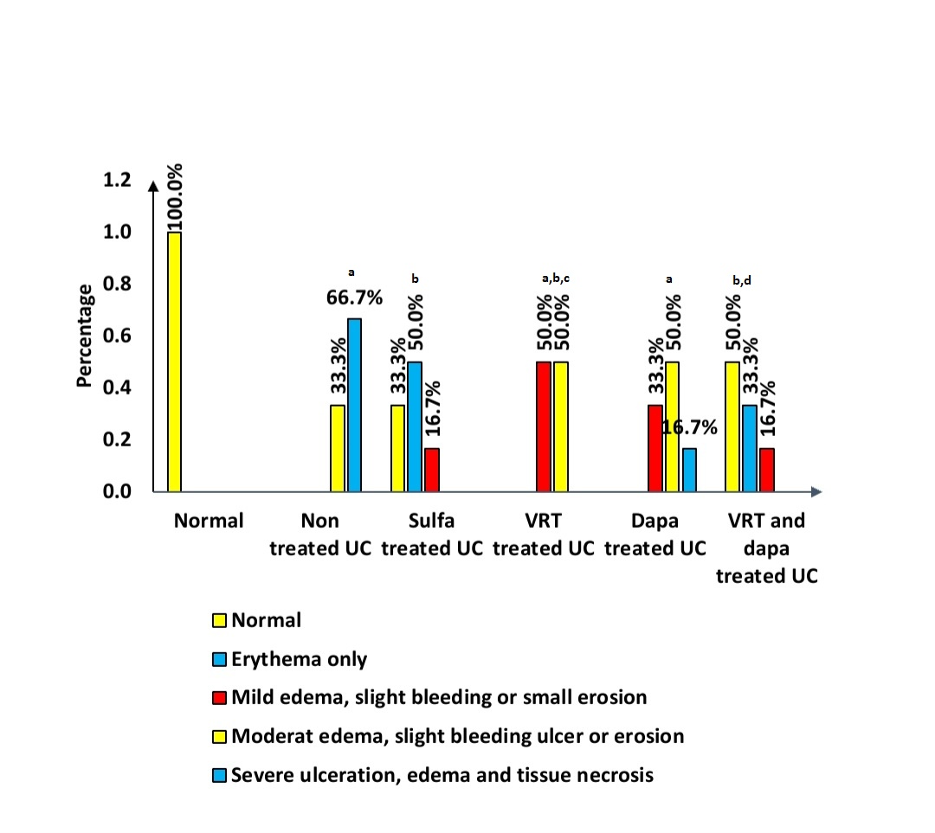
Fig ( 1): Effect of Prophylactic therapy of Sulfa at dose (100 mg /kg/ day, oral) , VRT (10 mg/kg/day, oral) and Dapa (5mg/kg/day, oral) for 2 weeks before and 1 week after induction of UC by single intra rectal injection of 2ml of 3% acetic acid on macroscopic examination in rats. Values are statistically different at p < 0.05.
a, Comparison between each group versus normal group;
b, Comparison between each group versus non treated group;
c, Comparison between each group versus sulfa treated group;
d, Comparison between each group versus VRT treated group;
e, Comparison between each group versus dapa treated group.

Effects of Sulfasalazine, Vortioxetine and Dapagliflozin on weight change along period of the study and disease activity index( DAI) in rats:
In table (4), There are a significant elevation in the DAI with a decrease in body weight in uc non treated rats if compared with normal rats, while rats received sulfa, VRT and Dapa showed significant reduction in DAI, a significant weight gain compared with UC non treated rats. The best significant improvement was seen in combination therapy treated group (VRT + Dapa).
Table 4. Prophylactic effect of Sulfasalazine at dose (100 mg /kg/ day, oral) , Vortioxetine (10 mg/kg/day, oral) and Dapagliflozin (5mg/kg/day, oral) for 2 weeks before and 1 week after induction of UC by single intra rectal injection of 2ml of 3% acetic acid for each rate on weight change along period of the study and DAI
Studied  groups  ParameterS | Normal | Non treated UC | Sulfa treated UC | VRT treated UC | Dapa treated UC | VRT and dapa treated UC
Body weight change % | 7.02±0.89 | 0.93ª±0.39 | 2.24^{a,b}±0.71 | 1.02^{a,b}±1.34 | 1.65^{a,b}±0.52 | 3.91^{a,b,c,d,e}±0.81
Disease activity index (DAI) score | 2.00±0.00 | 7.00ª±1.10 | 2.83^{a,b}±0.75 | 6.00^{a,c}±1.79 | 6.67^{a,c}±1.51 | 2.33 ^{b,d,e}± 0.52
a, Comparison between each group versus normal group;
b, Comparison between each group versus non treated group;
c, Comparison between each group versus sulfa treated group;
d, Comparison between each group versus VRT treated group;
e, Comparison between each group versus dapa treated group.
Values are means ±SD for 6 different rats per treatment. Values are statistically different at p < 0.05.

Effects of Sulfasalazine, Vortioxetine and Dapagliflozin on serum iNOS and CRP:
Serum iNOS and CRP was increase in colon tissues of UC non treated rats figure (2) A, B respectively compared to normal rats,while pretreatment with sulfa, VRT and Dapa showed significant decrease of serum iNOS and CRP. The best results were seen in combination therapy treated ulcerative rats (Fig 2) A, B.
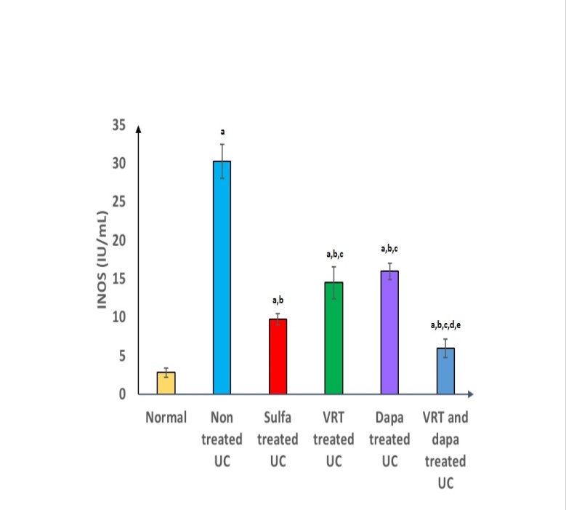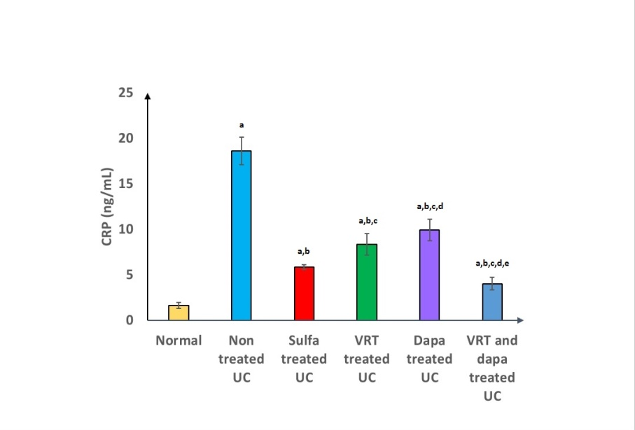
A
B
Fig (2): Effect of prophylactic therapy with of Sulfa at dose (100 mg /kg/ day, oral) , VRT (10 mg/kg/day, oral) and Dapa (5mg/kg/day, oral) for 2 weeks before and 1 week after induction of UC by single intra rectal injection of 2ml of 3% acetic acid on serum iNOS (A) and serum CRP (B) ) in rats.
a, Comparison between each group versus normal group;
b, Comparison between each group versus non treated group;
c, Comparison between each group versus sulfa treated group;
d, Comparison between each group versus VRT treated group;
e, Comparison between each group versus dapa treated group.
Values are means ±SD for 6 different rats per treatment. Values are statistically different at p < 0.05.
  - Impacts of Sulfasalazine, Vortioxetine and Dapagliflozin on colonic TNF-α and IL-10 in colon homogenates:
Figure (3) demonstrates a significant elevation in colonic TNF-α levels, decrease of colonic IL-10 in colon tissues of UC non treated rats(A, B respectively), while rats which received prophylactic therapy with sulfa, VRT and Dapa showed significant reduction in colonic TNF-α levels, with significant increase of colonic IL-10 if compared with UC non treated rats. The best significant improvement was seen in combined therapy (VRT + Dapa) treated ulcerative rats .
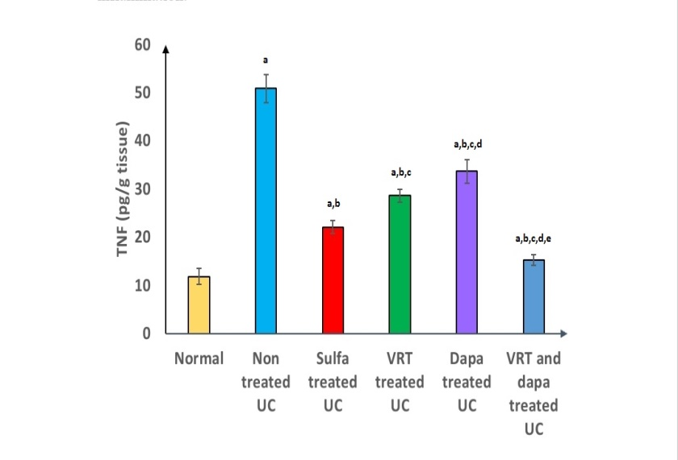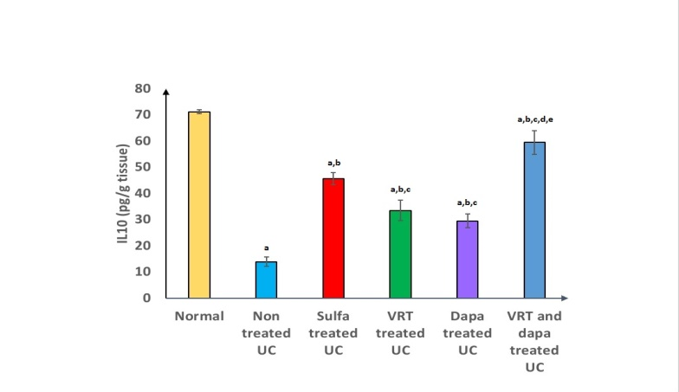
B
A
Fig (3): Prophylactic effect of Sulfa at dose (100 mg /kg/ day, oral) , VRT (10 mg/kg/day, oral) and Dapa (5mg/kg/day, oral) for 2 weeks before and 1 week after induction of UC by single intra rectal injection of 2ml of 3% acetic acid on colonic TNF-α (A) and colonic IL10(B) in rats.
a, Comparison between each group versus normal group;
b, Comparison between each group versus non treated group;
c, Comparison between each group versus sulfa treated group;
d, Comparison between each group versus VRT treated group;
e, Comparison between each group versus dapa treated group.
Values are means ±SD for 6 different rats per treatment. Values are statistically different at p < 0.05.
  - Effects of Sulfasalazine, Vortioxetine and Dapagliflozin on colonic MDA and colonic GSH in colon homogenates:
Figure (4) demonstrates a significant increase in colonic MDA levels, decrease of colonic GSH in colon tissues of UC non treated rats (A, B respectively), but rats which received prophylactic therapy with sulfa, VRT and Dapa showed significant decrease in colonic MDA with significant increase of colonic GSH if compared with UC non treated rats. The best significant findings were seen in combined therapy.
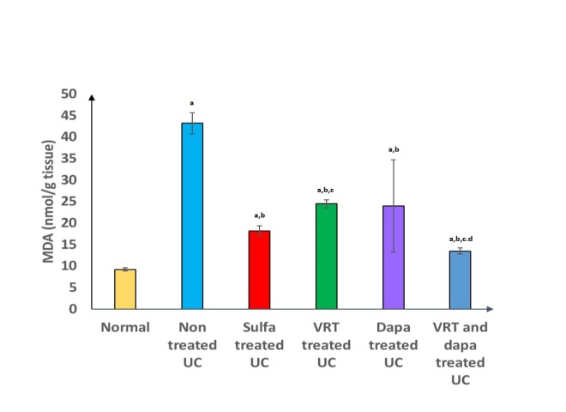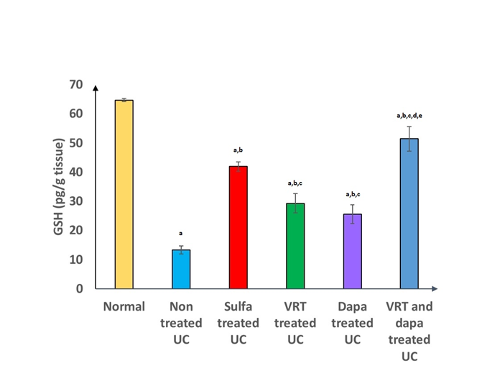
A
B
Fig (4): Effect of Prophylactic therapy of Sulfa at dose (100 mg /kg/ day, oral) , VRT (10 mg/kg/day, oral) and Dapa (5mg/kg/day, oral) for 2 weeks before and 1 week after induction of UC by single intra rectal injection of 2ml of 3% acetic acid on colonic MDA (A) and colonic GSH(B) in rats.
a, Comparison between each group versus normal group;
b, Comparison between each group versus non treated group;
c, Comparison between each group versus sulfa treated group;
d, Comparison between each group versus VRT treated group;
e, Comparison between each group versus dapa treated group.
Values are means ±SD for 6 different rats per treatment. Values are statistically different at p < 0.05.
  - Histopathological Examination:

The experimental groups’ colon histology was investigated in Figure 5. The normal group’s all the examined colon sections of rats revealed typical histoarchitecture of the mucosa, submucosa, muscularis and serosa. (Figure 5A), while the rats in ulcerative non treated group demonstrated substantial colon damage with markedly distorted colon histoarchitecture. A typical microscopic picture of ulcerative colitis was prevalent in the most examined colon sections. Mucosal disruption was evident, widespread necrosis and sloughing of the mucosal epithelium with ruptured crypts, There was also mononuclear infiltration of the underlying tissues (Figure 5B). On the other hand, Groups with pretreatment using sulfa, VRT and Dapa showed improvement in colon histological structure with the best improvement was seen in combined therapy (VRT + Dapa) treated ulcerative rats.(Figure 5C,D,E,F).

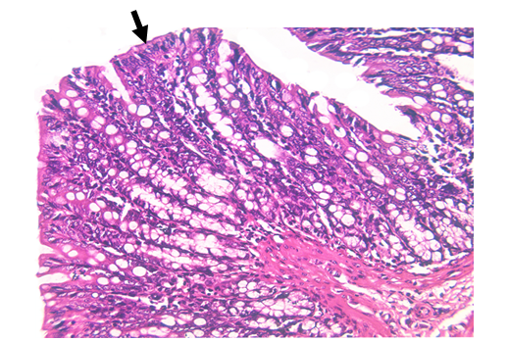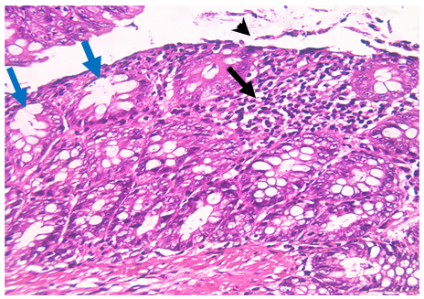
A
B
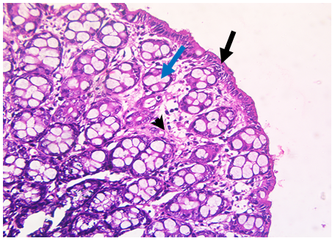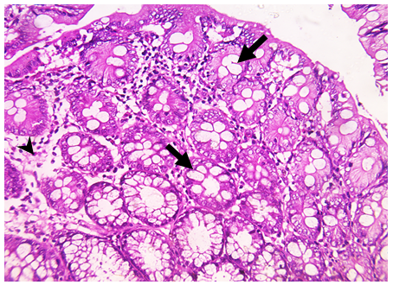
C
D
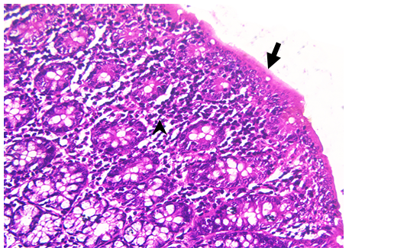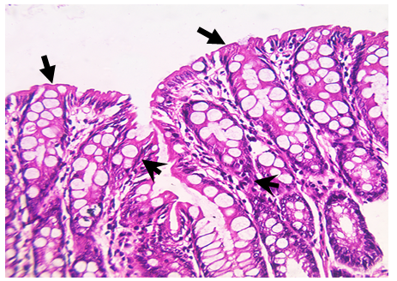
E
F

Figure 5. Impacts of prophylactic therapy with Sulfasalazine at dose (100 mg /kg/ day, oral) , Vortioxetine (10 mg/kg/day, oral) and Dapagliflozin (5mg/kg/day, oral) for 2 weeks before and 1 week after induction of UC by single intra rectal injection of 2ml of 3% acetic acid for each rate. (A): Normal group, Almost all the examined colon sections of rats revealed typical histoarchitecture of the mucosa, submucosa, muscularis and serosa. The mucosa was intact, folded and lined by simple columnar epithelial cells with many goblet cells(black arrows). (B): ulcerative non treated group showed showing extensive necrosis and sloughing of the mucosal epithelium with , loss of the superficial layer (black arrow heads) with crypt distortion (blue arrow) and mononuclear infiltration of the mucosa (black arrow). (C): sulfasalazine treated ulcerative group showed showing mild mucosal edema (black arrow head) and intact mucosal surface (black arrow) ,crypt irregularity(blue arrow). (D): Vortioxetine treated ulcerative group showed minimal mucosal edema (black arrow head )with crypt disruption (black arrow). (E): Dapagliflozin treated ulcerative group showed intact folded mucosa ( black arrow ) and many inflammatory cell infiltration of the colonic mucosa ( black arrow head).(F): Vortioxetine and dapagliflozine treated ulcerative group showed well-organized mucosa( black arrow ) and minimal inflammatory cell infiltration of the colonic mucosa( black arrow head) (H&E x200).

  - Immunohistochemical analysis of colonic expression of caspase-3:
The experimental groups’ colon immunohistochemical analysis was investigated in Figure 6. The normal group’s all the examined colon sections of rats revealed mild immunoexpression.(Figure6A), while the rats in ulcerative non treated group demonstrated strong immunoexpression in the lamina propria and the degenerated crypts. (Figure 5B). On the other hand, Groups with pretreatment using sulfa, VRT and Dapa showed improvement in caspase-3 immunoexpression with the best improvement was seen in combined therapy. (Figure 5C,D,E,F).
A
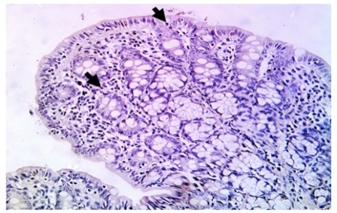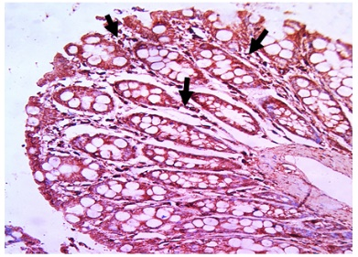
B
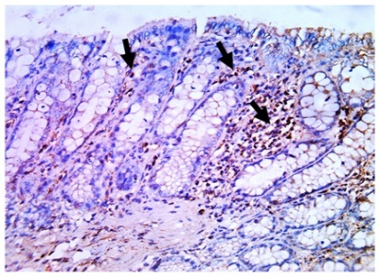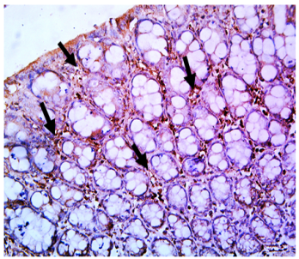
D
E
C
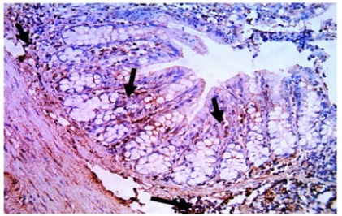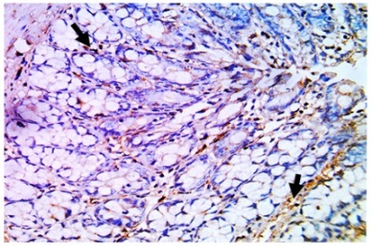
F

Figure 6. Prophylactic Effect of Sulfa at dose (100 mg /kg/ day, oral) , VRT (10 mg/kg/day, oral) and Dapa (5mg/kg/day, oral) for 2 weeks before and 1 week after induction of UC by single intra rectal injection of 2ml of 3% acetic acid on colon on immune histochemical changes of caspase3 protein expression in colonic tissue in rats (A):normal group showing mild immunoexpression. (B): non-treated group (UC group) showing strong immunoexpression in the lamina propria and the degenerated crypts.(C):sulfa pretreat group showing mild expression primarily in a few covering epithelium and lamina propria.(D):VRT pretreated group showing moderate expression in the covering epithelium, a few intestinal crypt cells, and interstitial tissues .(E): Dapa pretreated group showing moderate expression in some epithelial cells of the mucosa and crypts as well as within the interstitial tissue.(F): (VRT + dapa) pretreated group showing minimal expression in lamina propria and a few epithelial cells lining the crypts and mucosa. (black arrow indicate the positive expression) (IHC x200).
  - Immunohistochemical analysis of colonic expression of TGF-β:
The experimental groups’ colon Immunohistochemical analysis of TGF-β expression was investigated in Figure 7. The normal group’s all the examined colon sections of rats revealed minimal TGF-β immunoexpression in the mucosa and submucosa.(Figure7A), while the rats in ulcerative non treated group demonstrated showing intensive TGF-β immunoexpression in the mucosa. (Figure 7B). On the other hand, Groups with pretreatment using sulfa, VRT and Dapa showed improvement in TGF-β immunoexpression with the best improvement was seen in combined therapy (VRT + Dapa) treated ulcerative rats . (Figure 7C,D,E,F).
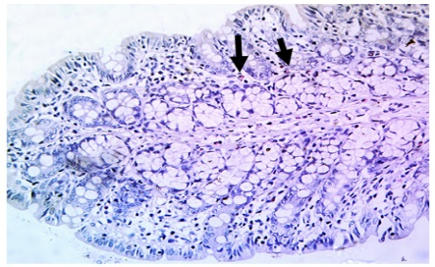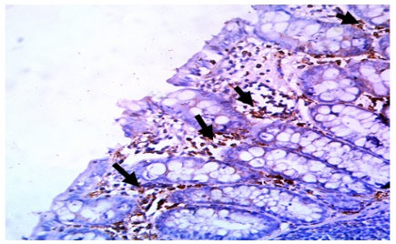
A
B
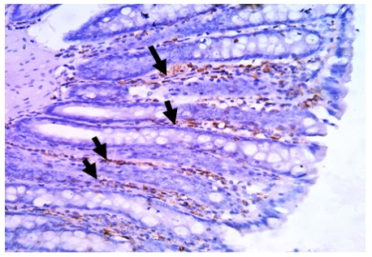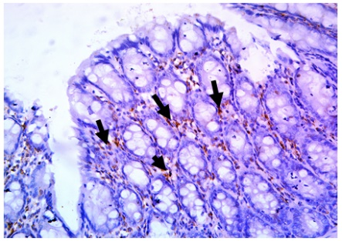
C
D
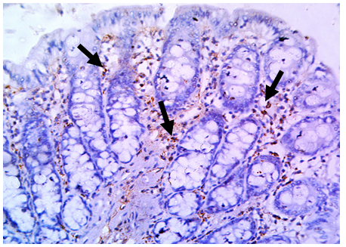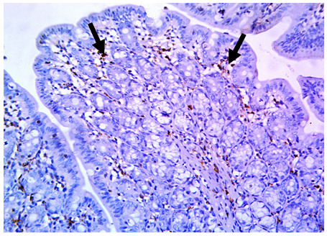
E
F

Figure 7. Prophylactic Effect of Sulfa at dose (100 mg /kg/ day, oral) , VRT (10 mg/kg/day, oral) and Dapa (5mg/kg/day, oral) for 2 weeks before and 1 week after induction of UC by single intra rectal injection of 2ml of 3% acetic acid on colon on immune histochemical changes of TGF-β protein expression in colonic tissue in rats (A):normal group showing minimal TGF-β immunoexpression in the mucosa and submucosa. (B): non-treated group (UC group) showing intensive TGF-β immunoexpression in the mucosa.(C):sulfa pretreat group showing weak TGF-β expression, between the crypts.(D):VRT pretreated group showing moderate TGF-β expression in interstitial tissues.(E): Dapa pretreated group showing moderate TGF-β expression in the mucosa and submucosa.(F): (VRT + dapa) pretreated group showing low TGF-β expression in colonic mucosa. (black arrow indicate the positive expression) (IHC x200).

Discussion:
UC can be experimentally- induced by intra-rectal administration of low concentration of acetic acid. This a well-known model for the study of IBD [17]. The acetic acid colitis model has been found efficient for experimental colitis in the rat [18]. The model is reproducible and shows a high similarity to human colitis.
The experimentally induced UC (non treated rats) showed a significant increase in colon weight, colon mass index (CMI) and colon weight/length ratio , these finding was in consistent with Khodir et al.[19] and ElMahdy et al.[11].Also, these UC untreated rats also showed significantly decreased colon length if compared with normal rats. The daily oral pre-treatment of UC rats with Sulfa, VRT and Dapa alone and in combination for 2 weeks before and 1 week after induction of UC resulted in significant decrease in the colon weight, CMI and weight/length ratio along with significant increase in the colon length compared with UC non treated rats. The best results were seen in (VRT + Dapa) treated group.
This is in agreement with Arab et al.[20] who found that Dapa as monotherapy significantly decreased the colon weight/length ratio, CMI compared to the UC non treated rats. To the best of our knowledge, our study is the first to evaluate the effect of VRT on UC on colon length, colon weight, CMI and weight/length ratio. These findings are parallel to those of Firouzabadi et al.[21] who mentioned that there was a significant decrease in colon weight/length ratio in rats treated with escitalopram (a selective serotonin reuptake inhibitor) compared to the UC non-treated group.
An explanation of this is supported by El-Rous et al.[10]who found that Dapa prevented colon shortening and caused a decline in the disease activity through targeting Nuclear factor kappa-light-chain-enhancer of activated B cells (NF-κB), AMP-activated protein kinase (AMPK), Nucleotide-binding domain-like receptor protein 3 (NLRP3) axis.
In our work, the intrarectal injection of acetic acid significantly increased the incidence of macroscopic damage index (MDI) namely severe ulceration, edema, and tissue necrosis when compared with normal rats [22],while pre-treatment of UC rats with Sulfa, VRT and Dapa alone and in combination, for 2 weeks before and 1 week after induction of UC, resulted in significant reduction in MDI if compared with UC non treated rats.
The same observation was noted by El-Mahdy et al.[11] who found that the MDI was significantly reduced in rats treated with Dapa.
Our results are also in agreement with Firouzabadi et al.[21] and Khazraei and Shamsdin.[23] who found that there was a significant decrease in MDI in escitalopram treated rats.
In the current study,acetic acid rectal administration exhibited a significant increase in the disease activity index (DAI) in non treated UC rats [10,22], as well as significant weight loss if compared with normal rats [24,25]. On other hand, the pre-treatment of UC rats with Sulfa, VRT and Dapa alone and in combination, orally daily for 2 weeks before and 1 week after induction of UC, resulted in a significant decrease in DAI and a significant weight gain compared with UC non treated rats. Noteworthy, the best improvement was seen in the combination therapy treated rats (VRT + Dapa).
Our finding are in line with a previous study by Arab et al.[20] who reported that Dapa attenuated the pathological symptoms of colitis in rats, as manifested by lowering the DAI. Also,VRT treated UC rats showed a decrease in DAI similarly as reported by Firouzabadi et al.[21] who found that there was a significant decrease in the DAI in escitalopram treated rats compared to the UC non-treated group.
Significant weight loss in UC non treated rats can be explained by nutrient deficiency resulting from decreased appetite, malabsorption, and fast loss of body fluids from colorectal bleeding. Taken into account, TNF-α and IL-6, both play an important role in body-weight loss induced by the secretion of neuropeptides, suppressing the appetite in colitis [26] , while Dapa explaination of improved clinical evaluation (DAI) , macroscopic scoring, prevented colon shortening and suppressed the disease activity through targeting the NF-κB/AMPK/NLRP3 axis El-Rous et al.[10].
It seems that the inflammation associated with UC contributed to the presence of oxidative stress in the colon with the production of reactive oxygen and nitrogen species (ROS, RNS) [27].
In the present study, UC non treated rats showed significant elevation of serum inducible nitric oxide Synthase (iNOS) [27,28], as well as serum C-Reactive protein (CRP) [11,19] if compared with normal control rats, but pre-treatment of UC rats with Sulfa, VRT and Dapa alone and in combination orally daily for 2 weeks before and 1 week after induction of UC resulted in significant decrease in serum iNOS as well as serum CRP if compared with UC non treated rats.
It was detected that treatment with Dapa shows decrease in serum iNOS compared to UC non treated group. Also, treatment with Dapa shows decrease in serum CRP compared to UC non treated group in concordance with Makaro et al.[29] 2024 and Yosef et al.[30].
VRT treated UC group shows decrease in serum iNOS similarly as reported by Caruso et al.[31] who demonstrated that both fluoxetine and VRT reduced the expression of iNOS mRNA in a rat model of oxidative stress induced by amyloid-beta oligomers.
The decline in serum CRP was observed in VRT treated group is agreeing with Kavakbasi et al.[32] who studied the anti-inflammatory effects of VRT combined with celecoxib.
In our study, UC untreated group showed significant elevation of colonic tumor necrosis factor alpha (TNF-α) if compared with normal rats [22,27]. with significant decrease of colonic interleukin10 (IL10) if compared with normal rats [33],while The pre-treatment of UC rats with Sulfa, VRT and Dapa alone and in combination resulted in significant decrease in colonic TNF-α and significant increase of colonic IL10 if compared with UC non treated rats.
Our results are in harmony with Arab et al.[10], El-Rous et al.[20] who found that Dapa monotherapy significantly decreased the levels of TNF-α, significant increase in the levels of colonic IL-10 respectively compared to those of untreated UC rats. Also, VRT treated UC group shows decrease in TNF-α similarly as reported by Shafiek et al.[34] who demonstrated that VRT suppressed phospho serine 536 nuclear factor kappa B (pS536 NF-κB p65) activity and reduced TNF-α production in experimental autoimmune encephalomyelitis model of multiple sclerosis in mice .
Dapa provided anti-ulcerogenic and colo-protective effects against experimentally induced UC in rats, primarily mediated via down regulation of of Monocyte Chemoattractant Protein 1 (MCP1), IL-18 signaling, and NF-κB expression [11].
Medications with SSRI activity like escitalopram are used in managing chronic and inflammatory pain. Since there is a bidirectional path between the inflammation caused in the brain and the gut, it is found that escitalopram directly suppresses the inflammation caused in UC by increasing the level of serotonin in the brain [24].
GSH is regarded as a free radical scavenger or a cellular oxidation inhibitor, and depletion of the GSH content is a marker of oxidative stress [35]. Accordingly, the GSH drop directly resulted in elevation of the MDA level, an end product of lipid peroxidation, which lead to polyunsaturated lipid degradation [36].
In the current study UC untreated rats showed significant increase of colonic MDA [19] as well as significant decrease of colonic GSH [19,27] if compared with normal rats, but pre-treatment of UC rats with Sulfa, VRT and Dapa alone and in combination orally daily for 2 weeks before and 1 week after induction of UC resulted in significant decrease in colonic MDA with significant increase of colonic GSH, if compared with UC non treated rats.
This is in agreement with Doğan and Uzun.[37], Bastawy et al.[38] who found that Dapa lowered MDA levels, increase in the levels of colonic GSH, compared to untreated groups respectively.Also, VRT treated UC group shows decrease in MDA similarly as reported by Fotache et al.[39] who demonstrated that VRT treatment resulted in a significant decrease in serum MDA levels in rats subjected to physical stress, indicating a reduction in oxidative stress, and in agreement with Cim et al.[40] who found that there was a significant decrease in MDA levels and significant increase in GSH levels in VRT treated rats model of stress-induced brain injury which indicate that VRT is a neuroprotective antidepressant with higher antioxidant activity .
Our results can be explained by that this reduction was linked to decreased expression of NADPH oxidase and other oxidative stress markers, suggesting a protective effect against oxidative damage, which could correlate with increased GSH levels in treated rats [41] ,while VRT explaination is that VRT is considered an inhibitor of Cytochrome P 450 (CYP 450), one of the major sources of ROS production, thus inhibition of CYP450 by VRT may substantially contribute to decline in oxidative stress observed in UC [42].
The data of this work revealed that experimental induction of UC resulted in colon damage with markedly distorted colon histoarchitecture, Mucosal disruption, widespread necrosis and sloughing of the mucosal epithelium with ruptured crypts and inflammatory cells infiltration .This is in line with Salama et al.[22] and El-Rous et al.[10] who reported that UC untreated rats revealed massive ulcerative hemorrhagic lesions associated with massive confluent necrosis along the mucosa, indicating a significant increase in the histological score compared to the control group, While pre-treatment of UC rats with Sulfa, VRT and Dapa alone and in combination resulted in a significant decrease in the microscopic and histological parameters.
This is in harmony with previous results by Arab et al.[20] who found that histopathologic examination of the control and dapagliflozin groups demonstrated an intact structure of mucosa with normal intestinal crypts, submucosa, musculosa, and serosa layers.
Furthermore, Apoptosis of intestinal epithelial cells has been considered an early event during the onset of UC and plays a crucial role in disease development [43].
In the current study, UC non treated rats showed significant upregulation of Caspase 3 immuno-expression if compared with normal rats [25] , but pre-treatment of UC rats with Sulfa, VRT and Dapa alone and in combination resulted in significant downregulation in Caspase 3 immuno- expression compared with UC non treated rats. The best Caspase 3 results was observed in in the combination therapy treated rats (VRT + Dapa).
In agreement with us, Arab et al.[20] revealed that treatment with Dapa evolved a significant decrease in Caspase-3 expression. Also our results are in agreement with Ozmen et al.[44] who found that VRT treatment was associated with reductions in caspase-3 and NF-κB levels, indicating its potential protective role against apoptosis and inflammation in cardiac tissues of a rat model of Cardiac Responses to Chronic Unpredictable Mild Stress .
An explanation of this protective effect of Dapa is supported and explained by Cheng et al .[45] study who reported that empagliflozin prevented beta-cell death by reducing glucotoxicity induced oxidative stress.
TGFβ1 serves as the key mediator of tissue fibrosis as it induces secretion of fibrillary collagens and promotes cell death and undifferentiation [46].
In our study, UC non treated rats showed significant upregulation of TGFβ immuno-expression if compared with normal rats [47,48]. The pre-treatment of UC rats with Sulfa, VRT and Dapa alone and in combination resulted in significant downregulation in TGFβ immuno expression compared with UC non treated rats. The best TGFβ improvement was observed in in the combination therapy treated rats (VRT + Dapa). To the best of our knowledge, this is the first study to evaluate the effect of Dapa and VRT on UC as regards TGF-β1 immuno-expression. This can be supported by Liashev et al.[49] study, where Sulfa decreases the expression levels of TGF-β. Also Chen et al.[50]study,that proved Dapa could further inhibit the expression of TGF-β1 compared with that of perindopril,Dapa exerted an inhibitory effect on the TGF-β1-Smad signaling pathway, showing a better cardioprotective effect than that of perindopril.Our results are also in agreement with Torrisi et al.[51] who found that treatment with Fluoxetine and VRT completely rescued hippocampal TGF-β1 levels in Aβ-injected mice as well as synaptophysin and PSD-95 levels.

Conclusion:
Current findings confirmed ameliorative impact of dapagliflozin and vortioxetine on UC induced by acetic acid. rats received combined therapy showed the best results as standard group (sulfa treated group ) but rats received mono therapy either VRT or dapa had the lowest prophylactic effect. UC altered colon length, colon weight, colon mass index , colon weight / length ratio, macroscopic examination, body weight,DAI, serum and colonic biomarkers, increased colonic inflammatory markers, colon lipid peroxidation in colon homogenate with altered different immun histochemical protein expression in colon tissue. The pre-administration of dapagliflozin and vortioxetine retrieved all altered markers at biochemical colon level, downregulated apoptosis and fibrosis. These results supported the potential use of dapagliflozin and vortioxetineto protect colon against UC.
Acknowledgments: The Pharmacology Department, Faculty of Medicine, Benha University, Egypt, provided technical and administrative assistance that was greatly appreciated by the authors throughout the course of this study.
References
- Tripathi, K. and Feuerstein, J.D. (2019): New developments in ulcerative colitis: Latest evidence on management, treatment, and maintenance. Drugs Context 8, 212572.
- Mahendra, G., & Hewavisenthi, J. (2022): The Role of the Pathologist in Ulcerative Colitis. In (Ed.), Ulcerative colitis - etiology, diagnosis, diet, special populations, and the role of interventional endoscopy [Working Title]. IntechOpen. https://doi.org/10.5772/intechopen.102072.
- Liu C, Zeng Y, Wen Y, Huang X and Liu Y (2022): Natural Products Modulate Cell Apoptosis: A Promising Way for the Treatment of Ulcerative Colitis. Front. Pharmacol.13:806148. doi: 10.3389/fphar.2022.806148.
- Vallerand, A.H.; Cynthia, A.; Sanoski, C.A. (2014): Davis's drug guide for nurses. (Fourteenth ed.). Philadelphia. ISBN 978-0-8036-4085 6. OCLC 881473728. Dis Treat. 10:1297–1307.
- Yaribeygi, H.; Katsiki, N.; Butler, A.E.; Sahebkar, A (2019): Effects of antidiabetic drugs on NLRP3 inflammasome activity, with a focus on diabetic kidneys. Drug Discov. Today 2019, 24, 256–262.
- Patti, A.M.; Rizvi, A.A.; Giglio, R.V.; Stoian, A.P.; Ligi, D.; Mannello, F. (2020): Impact of Glucose-Lowering Medications on Cardiometabolic Risk in Type 2 Diabetes. J. Clin. Med. 9, 91.
- Liao, X.; Wang, X.; Li. H.; Li, L.; Zhang, G.; Yang, M.; Yuan, L.; Liu, H.; Yang, G.; Gao, L. 2016): Sodium-Glucose Cotransporter 2 (SGLT2) Inhibitor Increases Circulating Zinc-A2-Glycoprotein Levels in Patients with Type 2 Diabetes. Sci. Rep.; 6: 32887.
- Soliman, N. A., Keshk, W. A., Rizk, F. H., & Ibrahim, M. A. (2019). The possible ameliorative effect of simvastatin versus sulfasalazine on acetic acid induced ulcerative colitis in adult rats. Chemico-biological interactions, 298, 57-65.‏
- Adamo, D., Calabria, E., Coppola, N., Pecoraro, G., & Mignogna, M. D. (2021). Vortioxetine as a new frontier in the treatment of chronic neuropathic pain: A review and update. Therapeutic Advances in Psychopharmacology, 11, 20451253211034320.‏
- El-Rous, M. A., Saber, S., Raafat, E. M., & Ahmed, A. A. (2021). Dapagliflozin, an SGLT2 inhibitor, ameliorates acetic acid-induced colitis in rats by targeting NFκB/AMPK/NLRP3 axis. Inflammopharmacology, 29(4), 1169-1185.‏
- ElMahdy, M. K., Antar, S. A., Elmahallawy, E. K., Abdo, W., Hijazy, H. H. A., Albrakati, A., & Khodir, A. E. (2021). A novel role of dapagliflozin in mitigation of acetic acid-induced ulcerative colitis by modulation of monocyte chemoattractant protein 1 (MCP-1)/nuclear factor-kappa B (NF-κB)/interleukin-18 (IL-18). Biomedicines, 10(1), 40.‏
- Jagtap, A. G., Shirke, S. S., & Phadke, A. S. (2004). Effect of polyherbal formulation on experimental models of inflammatory bowel diseases. Journal of ethnopharmacology, 90(2-3), 195-204.‏
- Palla, A. H., Iqbal, N. T., Minhas, K., & Gilani, A. H. (2016). Flaxseed extract exhibits mucosal protective effect in acetic acid induced colitis in mice by modulating cytokines, antioxidant and anti inflammatory mechanisms. International immunopharmacology, 38, 153-166.‏
- Abubakar, M. B., AbdullAh, W. Z., Sulaiman, S. A., & Ang, B. S. (2015). The effects of exposure to petrol vapours on growth, haematological parameters and oxidative markers in sprague-dawley male rats. The Malaysian journal of medical sciences: MJMS, 22(1), 23.‏
- Bancroft, J. D., & Layton, C. (2012). The hematoxylins and eosin. Bancroft’s theory and practice of histological techniques, 7, 173-186.‏
- Guesdon, J.L., Ternynck, T. A., vrameas, S. (1979) The use of avidin-biotin interaction in immunoenzymatic techniques. J Histochem Cytochem 27(8):1131–1139.
- Aleisa, A. M., Al-Rejaie, S. S., Abuohashish, H. M., Ola, M. S., Parmar, M. Y., & Ahmed, M. M. (2014). Pretreatment of Gymnema sylvestre revealed the protection against acetic acid-induced ulcerative colitis in rats. BMC complementary and alternative medicine, 14, 1-11.‏
- Saber, S., Khalil, RM., Abdo, WS., Nassif, D., El-Ahwany, E. (2019): Olm- esartan ameliorates chemically-induced ulcerative colitis in rats via modulating NFκB and Nrf-2/HO-1 signaling crosstalk. Toxi- col Appl Pharmacol 364:120–132.
- Khodir, A. E., Atef, H., Said, E., ElKashef, H. A., & Salem, H. A. (2017). Implication of Nrf2/HO-1 pathway in the coloprotective effect of coenzyme Q10 against experimentally induced ulcerative colitis. Inflammopharmacology, 25, 119-135.‏
- Arab, H. H., Al-Shorbagy, M. Y., & Saad, M. A. (2021). Activation of autophagy and suppression of apoptosis by dapagliflozin attenuates experimental inflammatory bowel disease in rats: Targeting AMPK/mTOR, HMGB1/RAGE and Nrf2/HO-1 pathways. Chemico-biological interactions, 335, 109368.‏
- Firouzabadi, N., Alimoradi, N., Najafizadeh, M., & Najafizadeh, P. (2021). Effect of escitalopram on an acetic acid‐induced ulcerative colitis model. Clinical and Experimental Pharmacology and Physiology, 48(5), 782-790.‏
- Salama, R. M., Darwish, S. F., Shaffei, I. E., Elmongy, N. F., Afifi, M. S., & Abdel-Latif, G. A. (2020). Protective effect of Morus macroura Miq. fruit extract against acetic acid-induced ulcerative colitis in rats: Involvement of miRNA-223 and TNFα/NFκB/NLRP3 inflammatory pathway. bioRxiv, 2020-12.‏
- Khazraei, H., & Shamsdin, S. A. (2024). The anti-inflammatory effects of antidepressants on colitis. Gastroenterology and Hepatology From Bed to Bench, 17(1), 28.‏
- Minaiyan, M., Hajhashemi, V., Rabbani, M., Fattahian, E., & Mahzouni, P. (2015). Effect of venlafaxine on experimental colitis in normal and reserpinised depressed rats. Research in pharmaceutical sciences, 10(4), 295-306.‏
- Alsharif, I. A., Fayed, H. M., Abdel-Rahman, R. F., Abd-Elsalam, R. M., & Ogaly, H. A. (2022). Miconazole mitigates acetic acid-induced experimental colitis in rats: insight into inflammation, oxidative stress and Keap1/Nrf-2 signaling crosstalk. Biology, 11(2), 303.‏
- Hunschede, S., Kubant, R., Akilen, R., Thomas, S., & Anderson, G. H. (2017). Decreased appetite after high-intensity exercise correlates with increased plasma interleukin-6 in normal-weight and overweight/obese boys. Current developments in nutrition, 1(3), e000398.‏
- Kumar, V. L., Pandey, A., Verma, S., & Das, P. (2019). Protection afforded by methanol extract of Calotropis procera latex in experimental model of colitis is mediated through inhibition of oxidative stress and pro-inflammatory signaling. Biomedicine & Pharmacotherapy, 109, 1602-1609.‏
- Wang, X., Fang, C., Liu, X., Wei, W., Zhang, M., Chen, S., & Shi, F. (2021). High serum levels of iNOS and MIP-1α are associated with post-stroke depression. Neuropsychiatric Disease and Treatment, 2481-2487.‏
- Makaro, A., Świerczyński, M., Pokora, K., Sarniak, B., Kordek, R., Fichna, J., & Salaga, M. (2024). Empagliflozin attenuates intestinal inflammation through suppression of nitric oxide synthesis and myeloperoxidase activity in in vitro and in vivo models of colitis. Inflammopharmacology, 32(1), 377-392.‏
- Yosef, B., Kaddar, N., & Boubou, A. (2023). Evaluation of the Effect of Dapagliflozin on CRP Levels in Type 2 Diabetes Patients. Jordan Journal of Pharmaceutical Sciences, 313-321.‏
- Caruso, G., Grasso, M., Fidilio, A., Torrisi, S. A., Musso, N., Geraci, F., ... & XC ~CC`DDSSsszz556 Caraci, F. (2021). Antioxidant activity of fluoxetine and vortioxetine in a non-transgenic animal model of alzheimer’s disease. Frontiers in Pharmacology, 12, 809541.‏
- Kavakbasi, E., Sampson, E., Mills, N. T., Hori, H., Schwarte, K., Hohoff, C., ... & Baune, B. T. (2024). Inflammation‐stratified augmentation of vortioxetine with celecoxib: Results from a double‐blind, randomized, placebo‐controlled trial in major depressive disorder. Journal of Neurochemistry, 168(9), 1817-1825.‏
- Samiea, A., Yoon, J. S., Cheung, S. T., Chamberlain, T. C., & Mui, A. L. F. (2020). Interleukin-10 contributes to PGE2 signalling through upregulation of EP4 via SHIP1 and STAT3. PloS one, 15(4), e0230427.‏
- Shafiek, M. S., Mekky, R. Y., Nassar, N. N., El-Yamany, M. F., & Rabie, M. A. (2024). Vortioxetine ameliorates experimental autoimmune encephalomyelitis model of multiple sclerosis in mice via activation of PI3K/Akt/CREB/BDNF cascade and modulation of serotonergic pathway signaling. European Journal of Pharmacology, 982, 176929.‏
- Franco, R., & Cidlowski, J. A. (2012). Glutathione efflux and cell death. Antioxidants & redox signaling, 17(12), 1694-1713.‏
- Rana, S. V., Sharma, S., Prasad, K. K., Sinha, S. K., & Singh, K. (2014). Role of oxidative stress & antioxidant defence in ulcerative colitis patients from north India. Indian Journal of Medical Research, 139(4), 568-571.‏
- Dogan, Z., & Uzun, H. (2024). Effect of dapagliflozin on oxidative stress in heart embryonic H9c2 cardiomyocytes. International Journal of Medical Biochemistry, 7(1).‏6-12.
- Bastawy, N., El-Mosallamy, A. E., Aljuaydi, S. H., AbuBakr, H. O., Rasheed, R. A., Sadek, A. S., ... & Boushra, A. F. (2024). SGLT2 inhibitor as a potential therapeutic approach in hyperthyroidism-induced cardiopulmonary injury in rats. Pflügers Archiv-European Journal of Physiology, 1-19.‏
- Fotache, P. A., Mititelu-Tartau, L., Bogdan, M., Buca, B. R., Pavel, L. L., Pelin, A. M., ... & Popa, G. E. (2022). Magnesium potentiates the vortioxetine’s effects on physical performances and biological changes in exercise-induced stress in rats. Medicina, 58(10), 1363.‏
- Cim, E. F. A., Suleyman, Z., Suleyman, H., Yazici, G. N., & Coban, T. A. (2024). Effect of Sertraline and Vortioxetine on Stress-Induced Brain Injury in Rats: Biochemical and Histopathological Evaluations. Clinical Neuropharmacology, 47(6), 213-217.‏
- Chen, Y. Y., Wu, T. T., Ho, C. Y., Yeh, T. C., Sun, G. C., Tseng, C. J., & Cheng, P. W. (2022). Blocking of SGLT2 to eliminate NADPH-induced oxidative stress in lenses of animals with fructose-induced diabetes mellitus. International Journal of Molecular Sciences, 23(13), 7142.‏
- Nieuwstraten, C., Labiris, N. R., & Holbrook, A. (2006). Systematic overview of drug interactions with antidepressant medications. The Canadian Journal of Psychiatry, 51(5), 300-316.‏
- Iwamoto, M., Koji, T., Makiyama, K., KOBAYASHI, N., & NAKANE, P. K. (1996). Apoptosis of crypt epithelial cells in ulcerative colitis. The Journal of pathology, 180(2), 152-159.‏
- Ozmen, O., Tasan, S., & Unal, G. O. (2025). Vortioxetine’s Therapeutic Potential: Cardiac Responses to Chronic Unpredictable Mild Stress in a Rat Model. Arq. Bras. Cardiol., 122(2), e20240159.
- Cheng, S. T. W., Chen, L., Li, S. Y. T., Mayoux, E., & Leung, P. S. (2016). The effects of empagliflozin, an SGLT2 inhibitor, on pancreatic β-cell mass and glucose homeostasis in type 1 diabetes. PloS one, 11(1), e0147391.‏
- Kang, H. R., Cho, S. J., Lee, C. G., Homer, R. J., & Elias, J. A. (2007). Transforming growth factor (TGF)-β1 stimulates pulmonary fibrosis and inflammation via a Bax-dependent, Bid-activated pathway that involves matrix metalloproteinase-12. Journal of Biological Chemistry, 282(10), 7723-7732.‏
- Zhu, L., Gu, P., & Shen, H. (2019). Protective effects of berberine hydrochloride on DSS-induced ulcerative colitis in rats. International Immunopharmacology, 68, 242-251.‏
- Naghdalipour, M., Moradi, N., Fadaei, R., Rezghi Barez, S., Sayyahfar, S., Mokhtare, M., ... & Esteghamati, A. (2022). Alteration of miR-21, miR-433 and miR-590 tissue expression related to the TGF-β signaling pathway in ulcerative colitis patients. Archives of physiology and biochemistry, 128(5), 1170-1174.‏
- Liashev, A. Y., Mal, G. S., Solin, A. V., & Balanina, M. A. (2024). The effect of dalargin on growth factors content in experimental ulcerative colitis. Research Results in Pharmacology, 10(1), 67-73.‏
- Chen, X., Yang, Q., Bai, W., Yao, W., Liu, L., Xing, Y., Meng, C., Qi, P., Dang, Y., & Qi, X. (2022). Dapagliflozin Attenuates Myocardial Fibrosis by Inhibiting the TGF-β1/Smad Signaling Pathway in a Normoglycemic Rabbit Model of Chronic Heart Failure. Frontiers in pharmacology, 13, 873108. https://doi.org/10.3389/fphar.2022.873108.
- ‏ Torrisi, S. A., Geraci, F., Tropea, M. R., Grasso, M., Caruso, G., Fidilio, A., Musso, N., Sanfilippo, G., Tascedda, F., Palmeri, A., Salomone, S., Drago, F., Puzzo, D., Leggio, G. M., & Caraci, F. (2019). Fluoxetine and Vortioxetine Reverse Depressive-Like Phenotype and Memory Deficits Induced by Aβ1-42 Oligomers in Mice: A Key Role of Transforming Growth Factor-β1. Frontiers in pharmacology, 10, 693. https://doi.org/10.3389/fphar.2019.00693.

